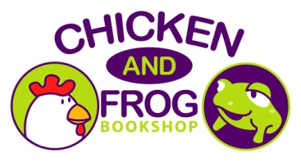
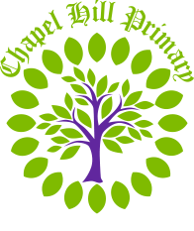

Dear Parents and carers,
We share and celebrate our love of reading here at Chapel Hill and we are delighted to be bringing the wonderful children’s author Kes Gray in to visit on Wednesday 2nd December 2026.
Kes will be speaking to the children about her books, writing, answering questions, giving them an insight into the world of an author and what it’s like to have your work made into a book.
You can purchase Kes’ brand-new book (One Night Before Christmas) before the visit, which he will be very happy to sign by bringing in an envelope with the completed form below and the exact cash. Please ensure that the envelope has written clearly on the front your child’s full name and class number so that we can ensure that we know where to deliver the books to once it has been signed.
Kes will only sign books purchased through here and won’t be able to sign pre-owned copies or ones purchased from elsewhere.
All orders must be returned to school no later than MONDAY 23RD NOVEMBER.
Kind regards,
Mrs Spencer
(English Subject Lead)
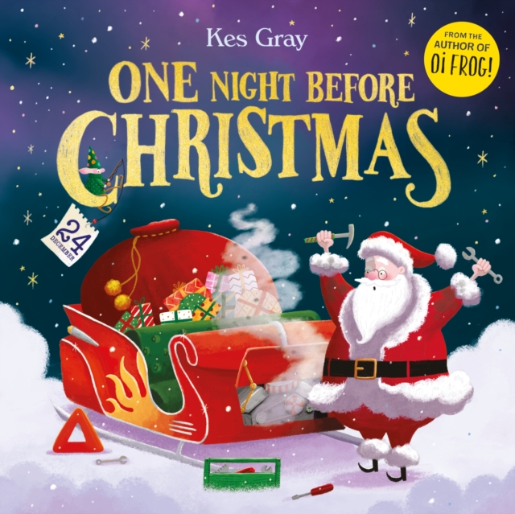

Title | Price | Quantity
One Night Before Christmas | £7.00
Child’s full name: ______________________________ Class: ____________________
Cash enclosed: __________________

